Story Graph of My Teaching Experience
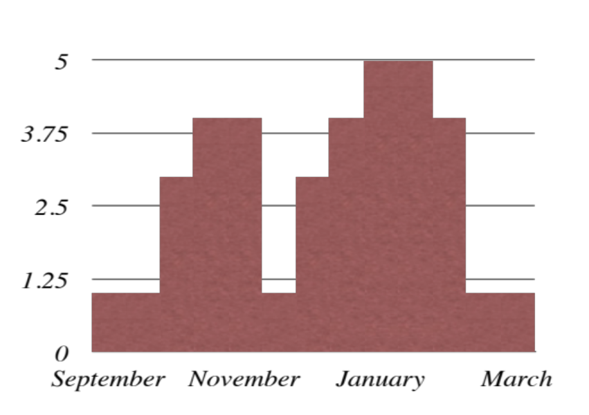

5= mostly positive and rewarding
4=Sometimes positive and rewarding
3=Neutral
2=Sometimes difficult and discouraging
1=Mostly difficult and discouraging

New BC teachers….2012

